Go to Mapping Definition. Create New Function.

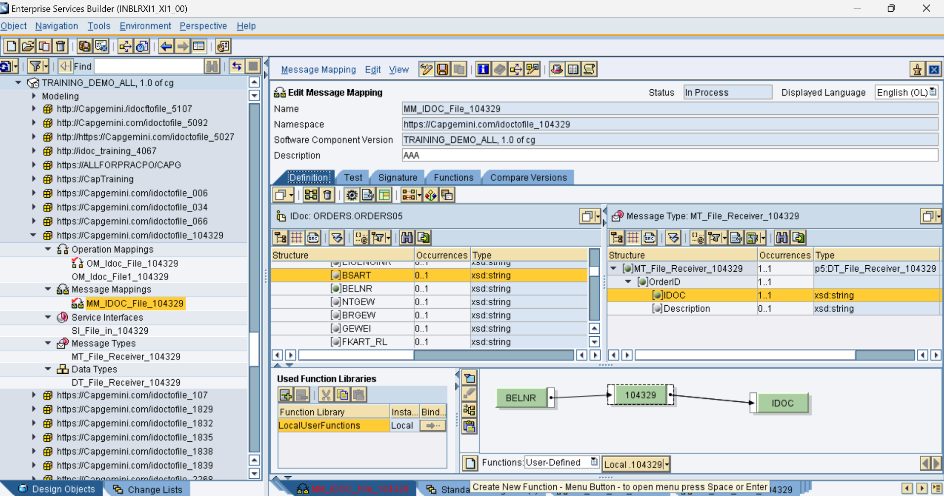

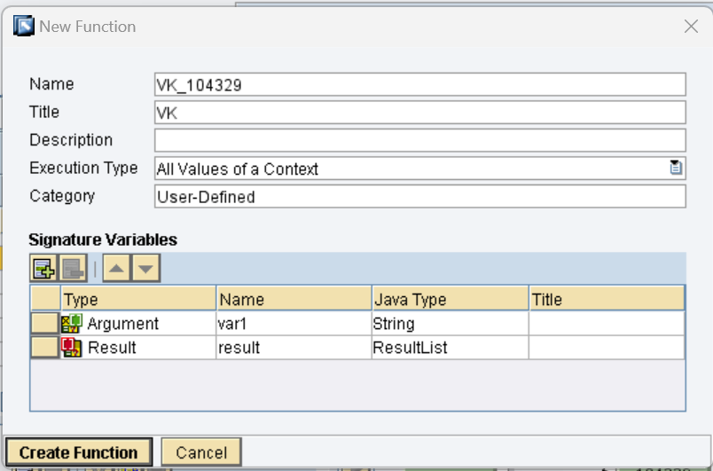

Click on Create Function and Enter the below code.

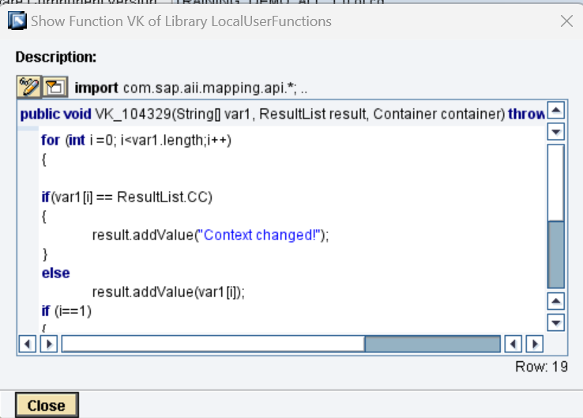

for (int i =0; i<var1.length;i++)

{

if(var1[i] == ResultList.CC)

{

result.addValue("Context changed!");

}

else

result.addValue(var1[i]);

if (i==1)

{

result.addValue(ResultList.CC);

}

if(i==var1.length -1)

{

result.addValue(ResultList.SUPPRESS);

}

}

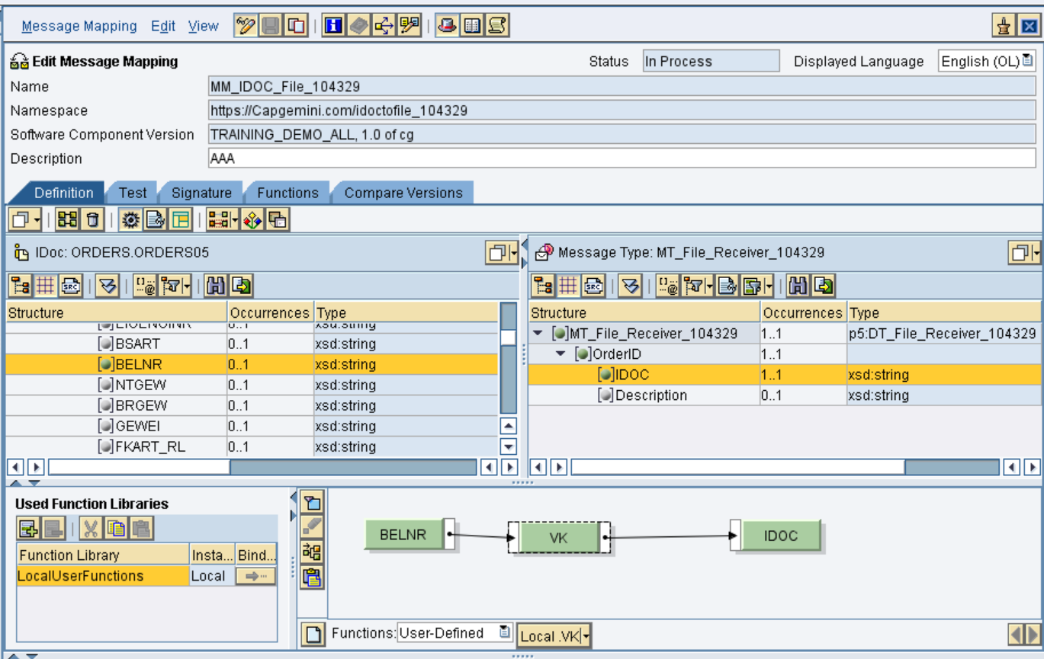

Right click on function module in above mapping, Click on Display Queue.

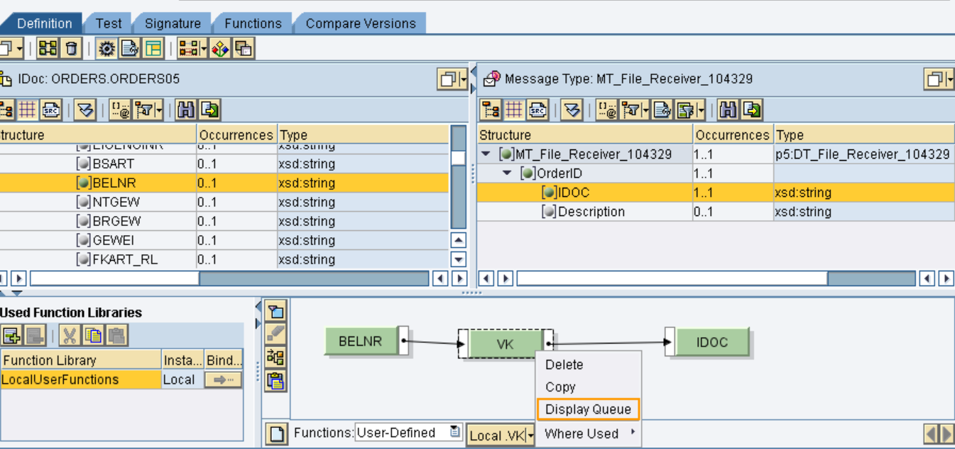

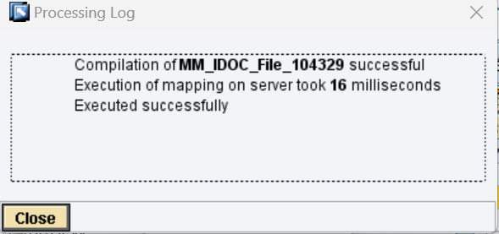

The below is when Belnr has a value of 11.

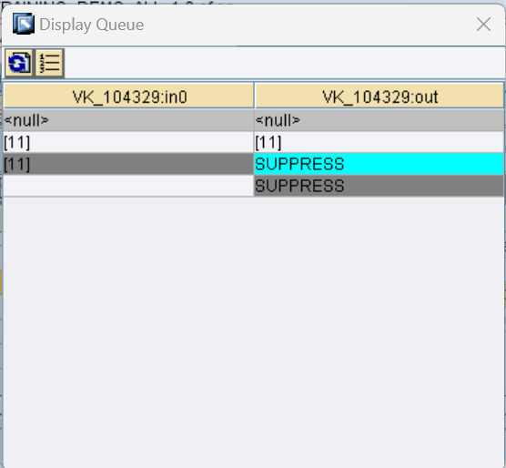

Test the mapping

